**14. Foreground/Background Processing**

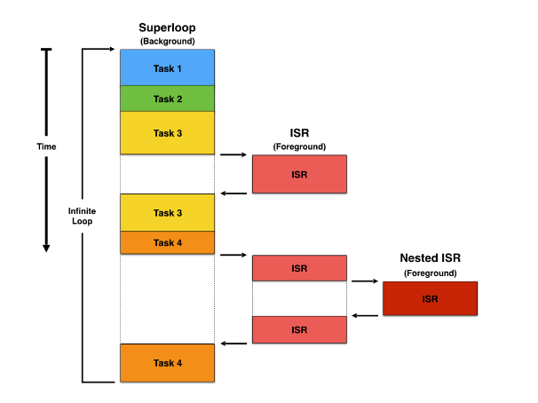**Recap on interrupts** – Foreground Processing

* Interrupt requiring attention = **ISR**
* 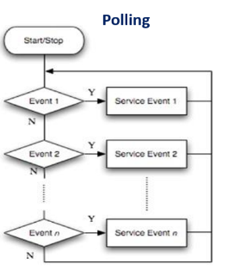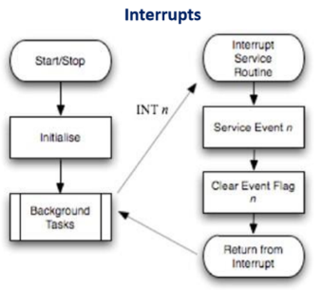Start address of an **ISR** = int. vector table (stored)

Polling = *Synchronous* Events

Interrupts = *Asynchronous* Events

Interrupts used when:

* Time completion = short
* Varying intervals/high avg rate
* Fore/Back model = simplify real-time system

**Foreground/background processing model**

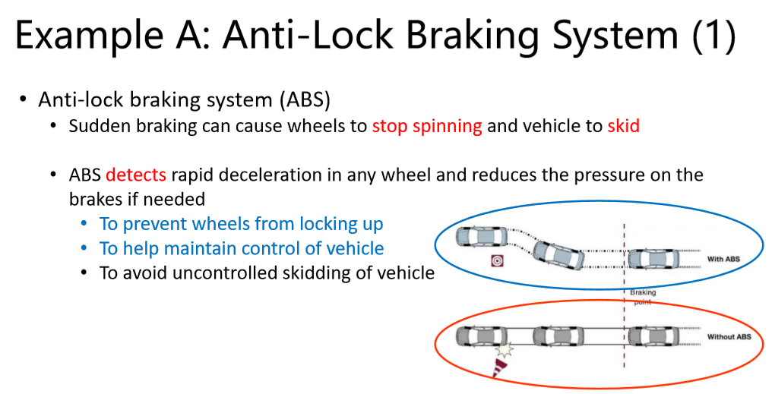Foreground:

* Interrupt driven ISR
* Require low latency

Background:

* All other time consuming
* Display tasks etc.
* 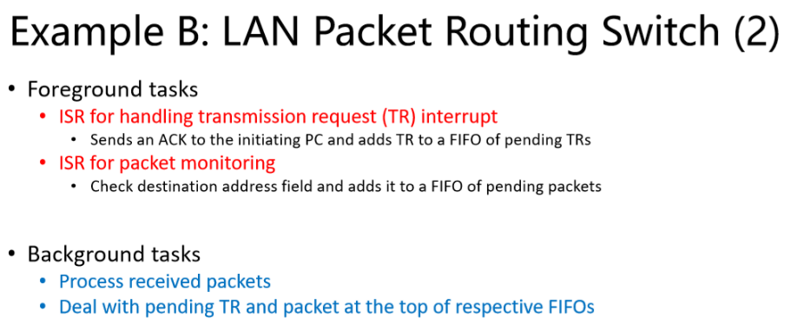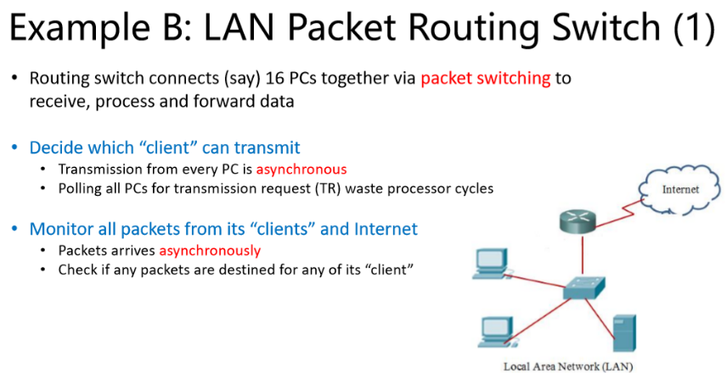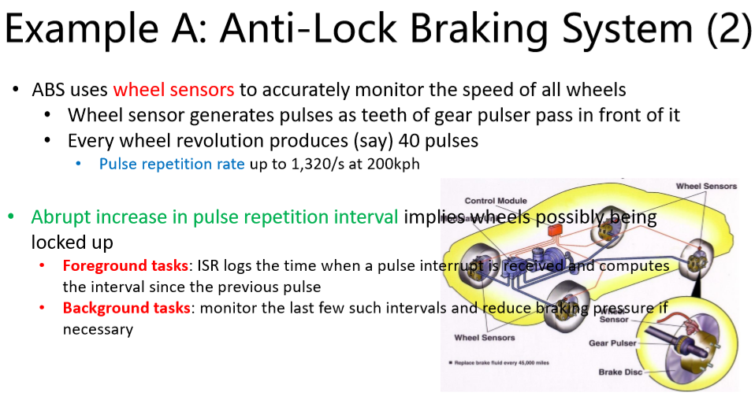Human interface ne eds

Queue